Australian time zone worksheet

USE THE MAPS OF AUSTRALIA BELOW TO ANSWER THE FOLLOWING QUESTIONS:
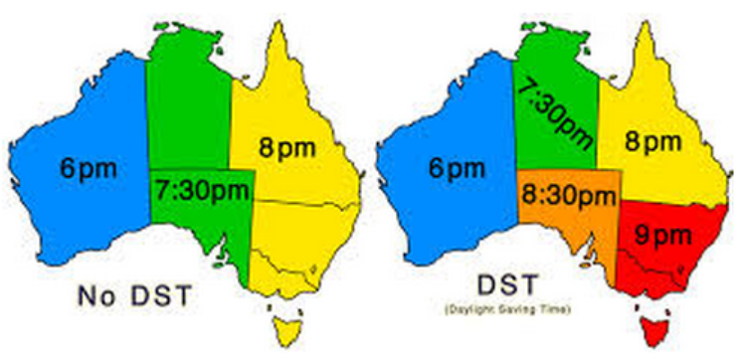
1. | If it is 10:30am in Brisbane in July, what time is it in:  - Sydney b) Adelaide
2. | If it is 8:45pm in Sydney in January, what time is it in:  - Perth b) Darwin
3. | What time is it in winter in:  - Perth if it is 4:30am in Brisbane?  - Adelaide if it is 1530 h in Melbourne?  - Gold Coast if it is noon in in Sydney?  - Perth if it is five-thirty in the evening in Melbourne?

4. | A Qantas flight schedule for a flight from Cairns to Adelaide and return is shown below. All times shown are local.  